**Week 6**

My Academy team at Cognizant want to create a dashboard containing the details of ongoing and completed cohorts. A react application is created which displays the detail of the cohorts using react component. You are assigned the task of styling these react components.

**CohortDetails.js**

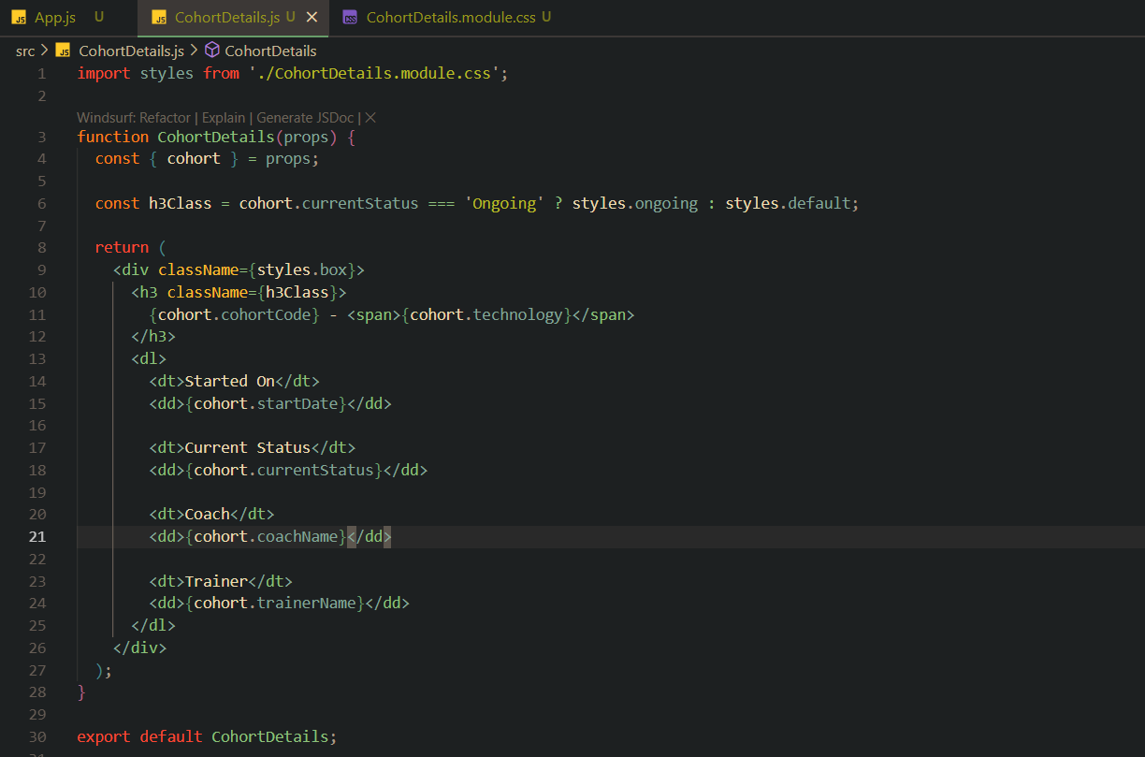

**CohortDetails.module.css**

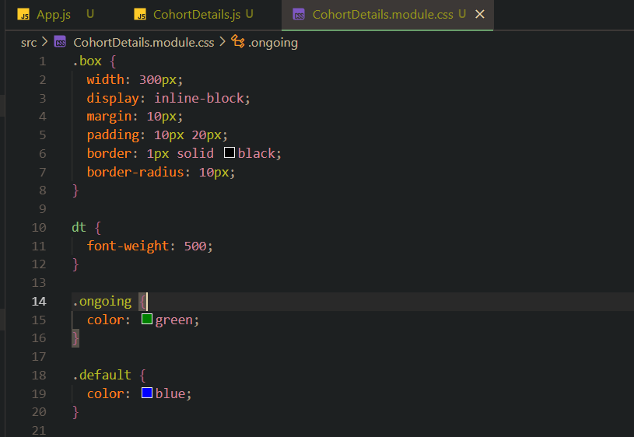

**App.js**

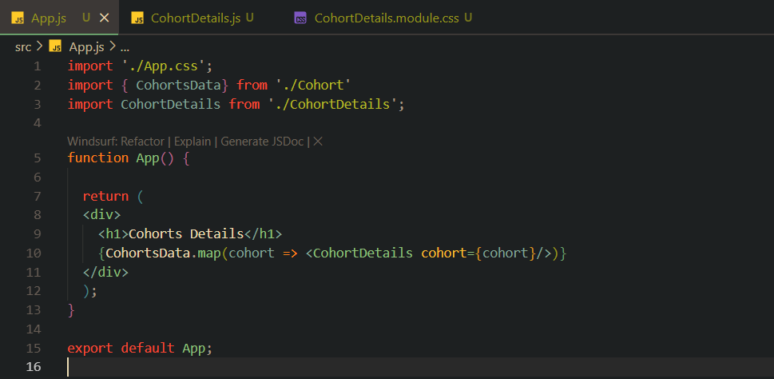

**Terminal**

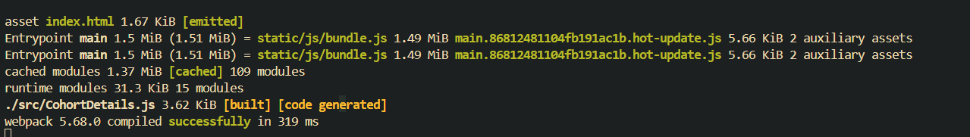

**Output (Browser)**

